An example how to calculate voltage drop and size of electrical cable
Posted Jun 30 2014 by jiguparmar in Cables, Energy and Power with 2 Comments
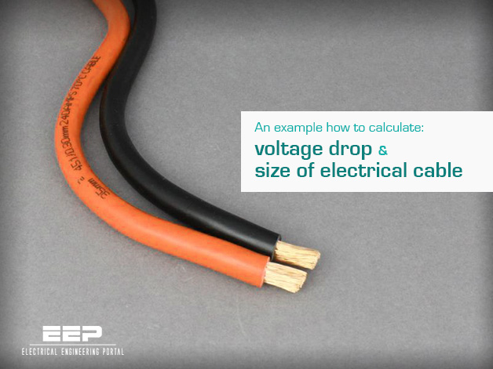
An example how to calculate voltage drop and size of electrical cable (photo credit: 12voltplanet.co.uk)

Input information

Electrical details:
Electrical load of 80KW, distance between source and load is 200 meters, system voltage 415V three phase, power factor is 0.8, permissible voltage drop is 5%, demand factor is 1.

Cable laying detail:
Cable is directed buried in ground in trench at the depth of 1 meter. Ground temperature is approximate 35 Deg. Number of cable per trench is 1. Number of run of cable is 1 run.

Soil details:
Thermal resistivity of soil is not known. Nature of soil is damp soil.

Ok, let’s dive into calculations…
- Consumed Load = Total Load · Demand Factor:
Consumed Load in KW = 80 · 1 = 80 KW
- Consumed Load in KVA = KW/P.F.:
Consumed Load in KVA = 80/0.8 = 100 KVA
- Full Load Current = (KVA · 1000) / (1.732 · Voltage):
Full Load Current = (100 · 1000) / (1.732 · 415) = 139 Amp.
Calculating Correction Factor of Cable from following data:

Temperature Correction Factor (K1) When Cable is in the Air
Temperature Correction Factor in Air: K1
Ambient Temperature | Insulation
 | PVC | XLPE/EPR
10 | 1.22 | 1.15
15 | 1.17 | 1.12
20 | 1.12 | 1.08
25 | 1.06 | 1.04
35 | 0.94 | 0.96
40 | 0.87 | 0.91
45 | 0.79 | 0.87
50 | 0.71 | 0.82
55 | 0.61 | 0.76
60 | 0.5 | 0.71
65 | 0 | 0.65
70 | 0 | 0.58
75 | 0 | 0.5
80 | 0 | 0.41

Ground Temperature Correction Factor (K2)
Ground Temperature Correction Factor: K2
Ground Temperature | Insulation
 | PVC | XLPE/EPR
10 | 1.1 | 1.07
15 | 1.05 | 1.04
20 | 0.95 | 0.96
25 | 0.89 | 0.93
35 | 0.77 | 0.89
40 | 0.71 | 0.85
45 | 0.63 | 0.8
50 | 0.55 | 0.76
55 | 0.45 | 0.71
60 | 0 | 0.65
65 | 0 | 0.6
70 | 0 | 0.53
75 | 0 | 0.46
80 | 0 | 0.38

Thermal Resistance Correction Factor (K4) for Soil (When Thermal Resistance of Soil is known)
Soil Thermal Resistivity: 2.5 KM/W
Resistivity | K3
1 | 1.18
1.5 | 1.1
2 | 1.05
2.5 | 1
3 | 0.96

Soil Correction Factor (K4) of Soil (When Thermal Resistance of Soil is not known)
Nature of Soil | K3
Very Wet Soil | 1.21
Wet Soil | 1.13
Damp Soil | 1.05
Dry Soil | 1
Very Dry Soil | 0.86

Cable Depth Correction Factor (K5)
Laying Depth (Meter) | Rating Factor
0.5 | 1.1
0.7 | 1.05
0.9 | 1.01
1 | 1
1.2 | 0.98
1.5 | 0.96

Cable Distance correction Factor (K6)
No of Circuit | Nil | Cable diameter | 0.125m | 0.25m | 0.5m
1 | 1 | 1 | 1 | 1 | 1
2 | 0.75 | 0.8 | 0.85 | 0.9 | 0.9
3 | 0.65 | 0.7 | 0.75 | 0.8 | 0.85
4 | 0.6 | 0.6 | 0.7 | 0.75 | 0.8
5 | 0.55 | 0.55 | 0.65 | 0.7 | 0.8
6 | 0.5 | 0.55 | 0.6 | 0.7 | 0.8

Cable Grouping Factor (No of Tray Factor) (K7)
No of Cable/Tray | 1 | 2 | 3 | 4 | 6 | 8
1 | 1 | 1 | 1 | 1 | 1 | 1
2 | 0.84 | 0.8 | 0.78 | 0.77 | 0.76 | 0.75
3 | 0.8 | 0.76 | 0.74 | 0.73 | 0.72 | 0.71
4 | 0.78 | 0.74 | 0.72 | 0.71 | 0.7 | 0.69
5 | 0.77 | 0.73 | 0.7 | 0.69 | 0.68 | 0.67
6 | 0.75 | 0.71 | 0.7 | 0.68 | 0.68 | 0.66
7 | 0.74 | 0.69 | 0.675 | 0.66 | 0.66 | 0.64
8 | 0.73 | 0.69 | 0.68 | 0.67 | 0.66 | 0.64

According to above detail correction factors:
- Ground temperature correction factor (K2) = 0.89
- Soil correction factor (K4) = 1.05
- Cable depth correction factor (K5) = 1.0
- Cable distance correction factor (K6) = 1.0
Total derating factor = k1 · k2 · k3 · K4 · K5 · K6 · K7
- Total derating factor = 0.93

Selection of Cable
For selection of proper cable following conditions should be satisfied:
- Cable derating amp should be higher than full load current of load.
- Cable voltage drop should be less than defined voltage drop.
- No. of cable runs ≥ (Full load current / Cable derating current).
- Cable short circuit capacity should be higher than system short circuit capacity at that point.

Selection of cable – Case #1
Let’s select 3.5 core 70 Sq.mm cable for single run.
- Current capacity of 70 Sq.mm cable is: 170 Amp,
Resistance = 0.57 Ω/Km and
Reactance = 0.077 mho/Km
- Total derating current of 70 Sq.mm cable = 170 · 0.93 = 159 Amp.
- Voltage Drop of Cable =
(1.732 · Current · (RcosǾ + jsinǾ) · Cable length · 100) / (Line voltage · No of run · 1000) =
(1.732 · 139 · (0.57 · 0.8 + 0.077 · 0.6) · 200 · 100) / (415 · 1 · 1000) = 5.8%
Voltage drop of cable = 5.8%
Here voltage drop for 70 Sq.mm Cable (5.8 %) is higher than define voltage drop (5%) so either select higher size of cable or increase no of cable runs.
If we select 2 runs, than voltage drop is 2.8% which is within limit (5%) but to use 2 runs of cable of 70 Sq.mm cable is not economical, so it’s necessary to use next higher size of cable.

Selection of cable – Case #2
Let’s select 3.5 core 95 Sq.mm cable for single run, short circuit capacity = 8.2 KA.
- Current capacity of 95 Sq.mm cable is 200 Amp,
Resistance = 0.41 Ω/Km and
Reactance = 0.074 mho/Km
- Total derating current of 70 Sq.mm Cable = 200 · 0.93 = 187 Amp.
- Voltage drop of cable =
(1.732 · 139 · (0.41 · 0.8 + 0.074 · 0.6) · 200 · 100) / (415 · 1 · 1000) = 2.2%
To decide 95 Sq.mm cable, cable selection condition should be checked.
- Cable derating Amp (187 Amp) is higher than full load current of load (139 Amp) = O.K
- Cable voltage Drop (2.2%) is less than defined voltage drop (5%) = O.K
- Number of cable runs (1) ≥ (139A / 187A = 0.78) = O.K
- Cable short circuit capacity (8.2KA) is higher than system short circuit capacity at that point (6.0KA) = O.K
95 Sq.mm cable satisfied all three condition, so it is advisable to use 3.5 Core 95 Sq.mm cable.

